**9. ReactJS-HOL**

**ListofPlayers,js:**

import React from 'react';

const ListofPlayers = () => {

const players = [

{ name: "Virat", score: 85 },

{ name: "Rohit", score: 60 },

{ name: "Gill", score: 45 },

{ name: "Hardik", score: 90 },

{ name: "Rahul", score: 55 },

{ name: "Jadeja", score: 70 },

{ name: "Pant", score: 30 },

{ name: "Bumrah", score: 75 },

{ name: "Shami", score: 65 },

{ name: "Ashwin", score: 50 },

{ name: "Surya", score: 80 },

];

const below70 = players.filter(player => player.score < 70);

return (

<div>

<h2>All Players</h2>

{players.map((player, index) => (

<p key={index}>{player.name} - {player.score}</p>

))}

<h2>Players with score below 70</h2>

{below70.map((player, index) => (

<p key={index}>{player.name} - {player.score}</p>

))}

</div>

);

}

export default ListofPlayers;

**IndianPlayers.js:**

import React from 'react';

const IndianPlayers = () => {

const T20players = ["Kohli", "Rohit", "Hardik", "Pant"];

const RanjiTrophy = ["Iyer", "Jadeja", "Ashwin", "Rahane"];

const merged = [...T20players, ...RanjiTrophy];

const [p1, p2, p3, p4, ...rest] = merged;

const oddPlayers = merged.filter((_, index) => index % 2 === 0);

const evenPlayers = merged.filter((_, index) => index % 2 !== 0);

return (

<div>

<h2>Merged Players</h2>

<p>{merged.join(", ")}</p>

<h3>Odd Team Players:</h3>

<ul>

{oddPlayers.map((player, i) => <li key={i}>{player}</li>)}

</ul>

<h3>Even Team Players:</h3>

<ul>

{evenPlayers.map((player, i) => <li key={i}>{player}</li>)}

</ul>

</div>

);

};

export default IndianPlayers;

**App.js:**

import React from 'react';

import ListofPlayers from './components/ListofPlayers';

import IndianPlayers from './components/IndianPlayers';

function App() {

const flag = true;

return (

<div className="App">

<h1>🏏 Cricket App</h1>

{flag ? <ListofPlayers /> : <IndianPlayers />}

</div>

);

}

export default App;

**OUTPUT:**

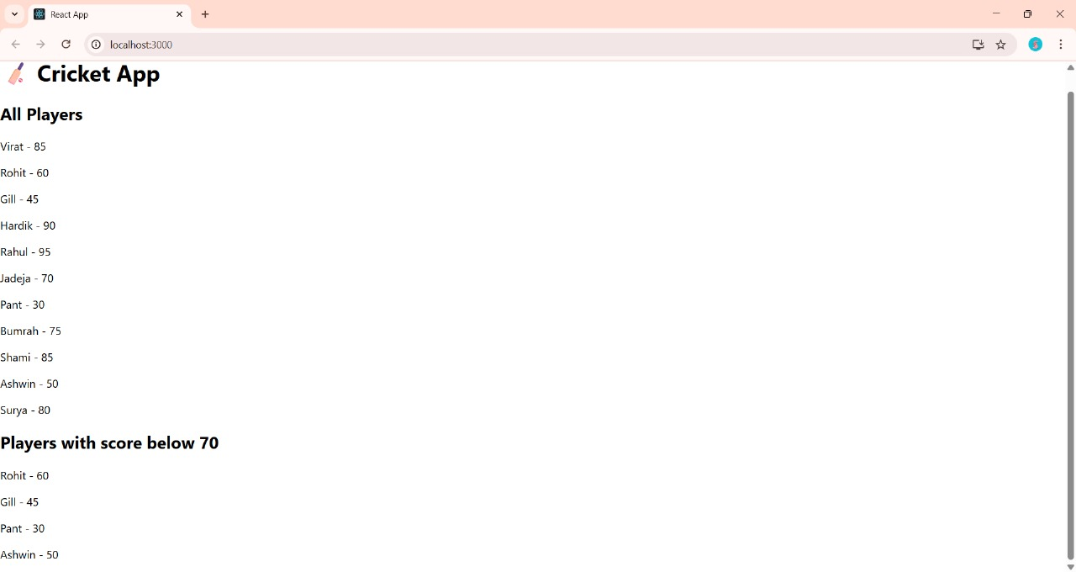

**10. ReactJS-HOL**

**App.js:**

import React from 'react';

import officeImg from './Office1.jpg';

function App() {

const heading = <h1>Office Space Rental List</h1>;

const office = {

name: "Sky Tower",

rent: 55000,

address: "123, Anna Salai, Chennai"

};

const officeList = [

{ name: "Sky Tower", rent: 55000, address: "123, Anna Salai, Chennai" },

{ name: "Green Park", rent: 75000, address: "Velachery, Chennai" },

{ name: "Ocean View", rent: 60000, address: "ECR Road, Chennai" },

{ name: "Cloud Nine", rent: 45000, address: "OMR, Chennai" },

];

return (

<div style={{ padding: "20px", fontFamily: "Arial" }}>

{heading}

<img src={officeImg} alt="Office Space" width="300" />

<h2>Featured Office</h2>

<p><b>Name:</b> {office.name}</p>

<p>

<b>Rent:</b>{" "}

<span style={{ color: office.rent > 60000 ? "green" : "red" }}>

₹{office.rent}

</span>

</p>

<p><b>Address:</b> {office.address}</p>

<h2>Available Office Spaces</h2>

{officeList.map((item, index) => (

<div key={index} style={{ borderBottom: "1px solid #ccc", marginBottom: "10px" }}>

<p><b>Name:</b> {item.name}</p>

<p>

<b>Rent:</b>{" "}

<span style={{ color: item.rent > 60000 ? "green" : "red" }}>

₹{item.rent}

</span>

</p>

<p><b>Address:</b> {item.address}</p>

</div>

))}

</div>

);

}

export default App;

**OUTPUT:**

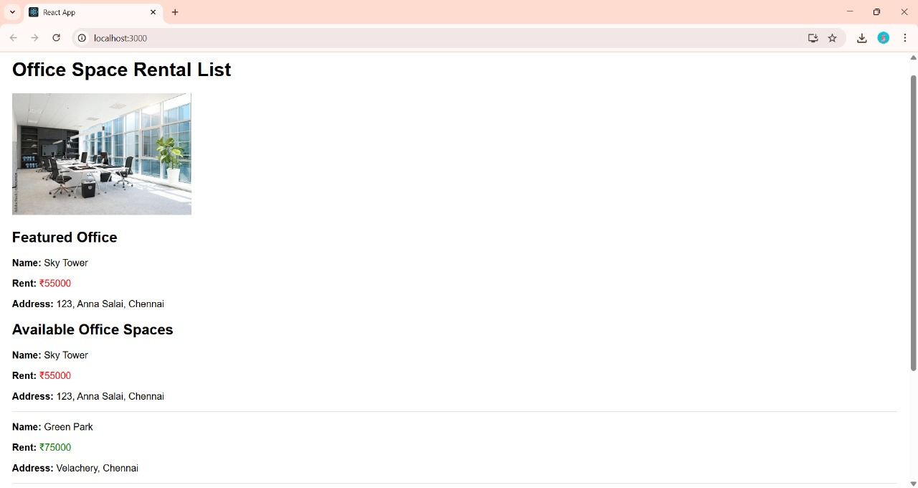

**11. ReactJS-HOL**

**App.js:**

import React, { Component } from 'react';

import CurrencyConvertor from './CurrencyConvertor';

class App extends Component {

constructor(props) {

super(props);

this.state = {

count: 0,

};

}

increment = () => {

this.setState({ count: this.state.count + 1 });

this.sayHello();

};

decrement = () => {

this.setState({ count: this.state.count - 1 });

};

sayHello = () => {

console.log("Hello! This is a static message.");

alert("Hello! This is a static message.");

};

sayWelcome = (message) => {

alert(Welcome message: ${message});

};

handleClick = (event) => {

console.log("Synthetic Event triggered!");

alert("I was clicked");

};

render() {

return (

<div style={{ textAlign: 'center' }}>

<h1>React Event Handling Example</h1>

<h2>Counter: {this.state.count}</h2>

<button onClick={this.increment}>Increment</button>

<button onClick={this.decrement}>Decrement</button>

<br /><br />

<button onClick={() => this.sayWelcome("welcome")}>Say Welcome</button>

<br /><br />

<button onClick={this.handleClick}>Synthetic Event Button</button>

<br /><br />

<CurrencyConvertor />

</div>

);

}

}

export default App;

**CurrencyConvertor.js:**

import React, { useState } from 'react';

function CurrencyConvertor() {

const [rupees, setRupees] = useState("");

const [euro, setEuro] = useState("");

const handleConvert = () => {

const rate = 0.011; // Example: 1 INR = 0.011 EUR

setEuro((rupees * rate).toFixed(2));

};

const handleReverse = () => {

const rate = 91; // Example: 1 EUR = 91 INR

setRupees((euro * rate).toFixed(2));

};

return (

<div style={{ marginTop: "30px" }}>

<h2>Currency Convertor</h2>

<input

type="number"

placeholder="Enter amount in INR"

value={rupees}

onChange={(e) => setRupees(e.target.value)}

/>

<button onClick={handleConvert}>Convert to Euro</button>

<br /><br />

<input

type="number"

placeholder="Enter amount in EUR"

value={euro}

onChange={(e) => setEuro(e.target.value)}

/>

<button onClick={handleReverse}>Convert to INR</button>

<p>INR: ₹{rupees}</p>

<p>EUR: €{euro}</p>

</div>

);

}

export default CurrencyConvertor;

**OUTPUT:**

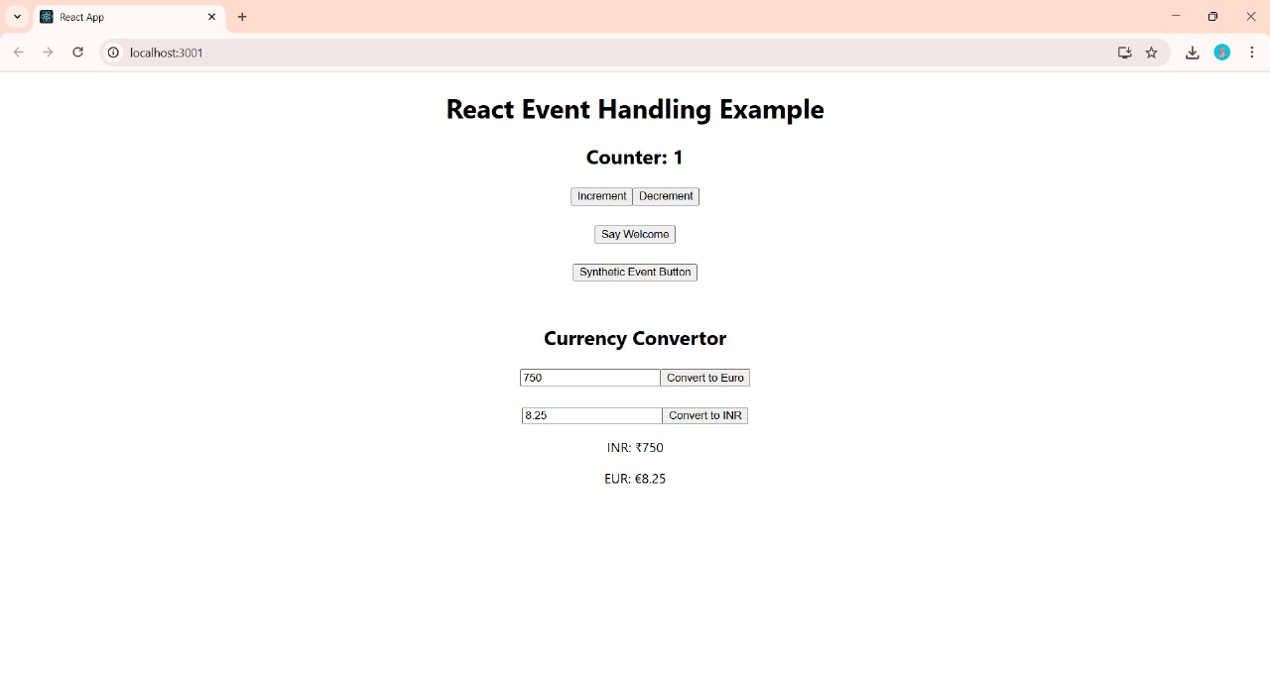

**13. ReactJS-HOL**

.App {

text-align: center;

}

.App-logo {

height: 40vmin;

pointer-events: none;

}

@media (prefers-reduced-motion: no-preference) {

.App-logo {

animation: App-logo-spin infinite 20s linear;

}

}

.App-header {

background-color: #282c34;

min-height: 100vh;

display: flex;

flex-direction: column;

align-items: center;

justify-content: center;

font-size: calc(10px + 2vmin);

color: white;

}

.App-link {

color: #61dafb;

}

@keyframes App-logo-spin {

from {

transform: rotate(0deg);

}

to {

transform: rotate(360deg);

}

}

{

"name": "ticketbookingapp",

"version": "0.1.0",

"private": true,

"dependencies": {

"@testing-library/dom": "^10.4.1",

"@testing-library/jest-dom": "^6.6.4",

"@testing-library/react": "^16.3.0",

"@testing-library/user-event": "^13.5.0",

"react": "^19.1.1",

"react-dom": "^19.1.1",

"react-scripts": "5.0.1",

"web-vitals": "^2.1.4"

},

"scripts": {

"start": "react-scripts start",

"build": "react-scripts build",

"test": "react-scripts test",

"eject": "react-scripts eject"

},

"eslintConfig": {

"extends": [

"react-app",

"react-app/jest"

]

},

"browserslist": {

"production": [

">0.2%",

"not dead",

"not op_mini all"

],

"development": [

"last 1 chrome version",

"last 1 firefox version",

"last 1 safari version"

]

}

}

**OUTPUT:**

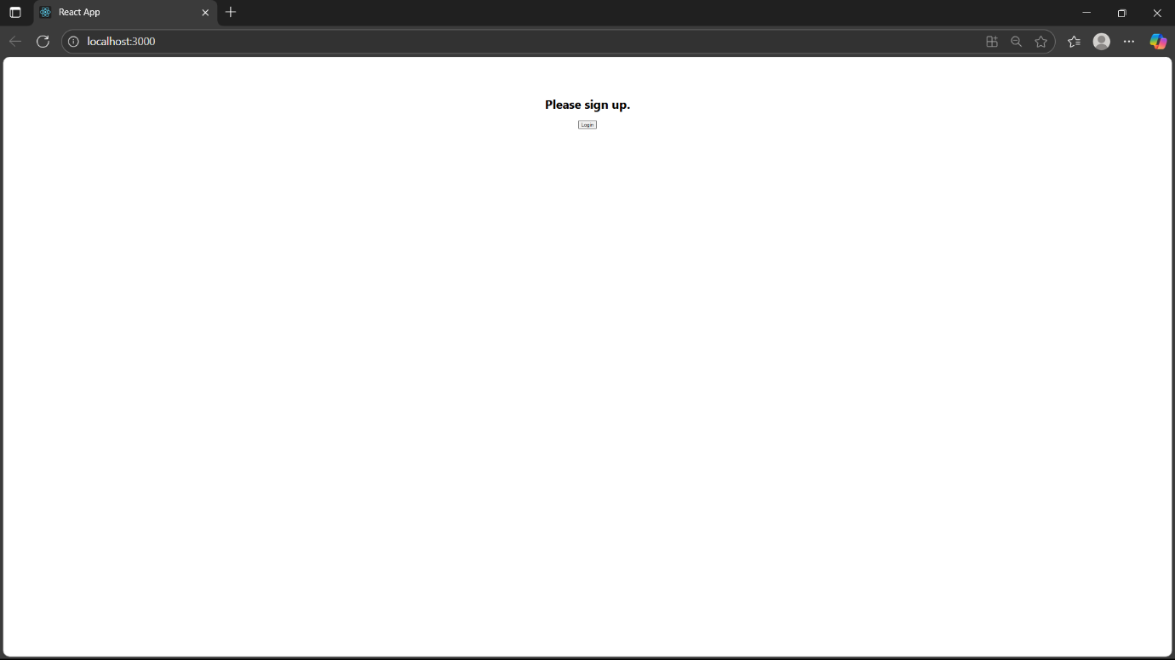

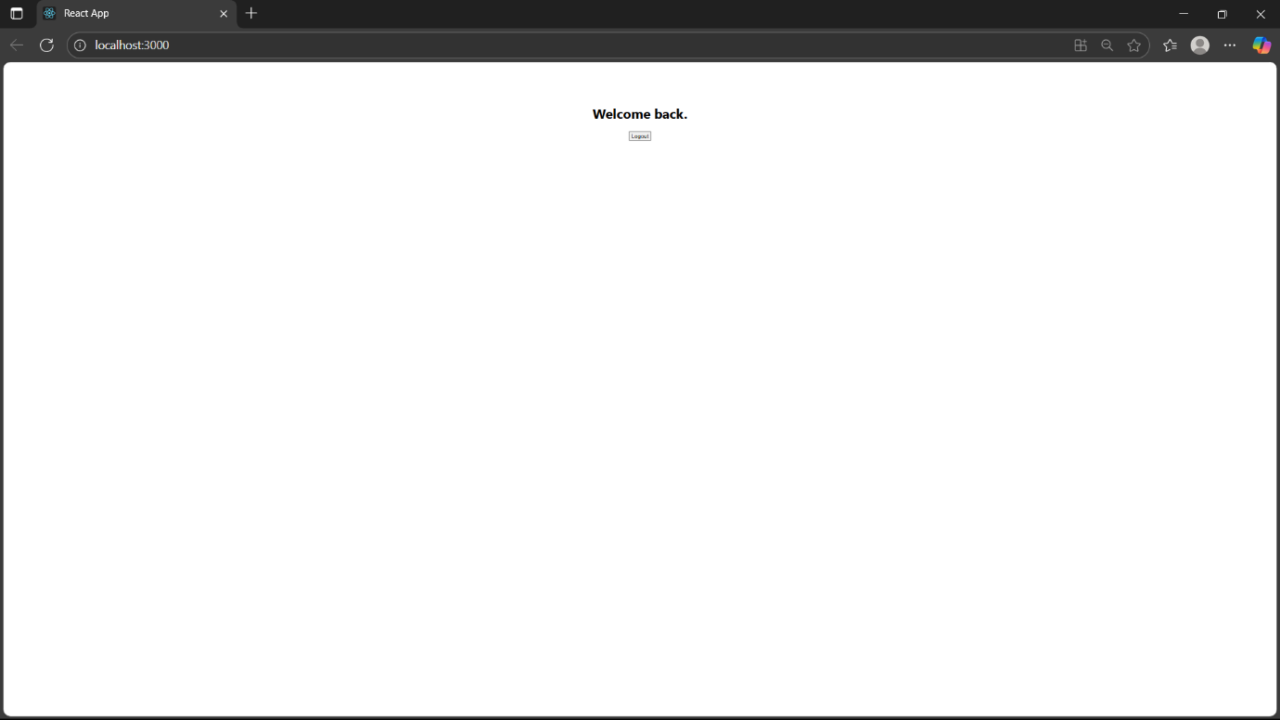

**13. ReactJS-HOL**

**App.js:**

{

"short_name": "React App",

"name": "Create React App Sample",

"icons": [

{

"src": "favicon.ico",

"sizes": "64x64 32x32 24x24 16x16",

"type": "image/x-icon"

},

{

"src": "logo192.png",

"type": "image/png",

"sizes": "192x192"

},

{

"src": "logo512.png",

"type": "image/png",

"sizes": "512x512"

}

],

"start_url": ".",

"display": "standalone",

"theme_color": "#000000",

"background_color": "#ffffff"

}

.App {

text-align: center;

}

.App-logo {

height: 40vmin;

pointer-events: none;

}

@media (prefers-reduced-motion: no-preference) {

.App-logo {

animation: App-logo-spin infinite 20s linear;

}

}

.App-header {

background-color: #282c34;

min-height: 100vh;

display: flex;

flex-direction: column;

align-items: center;

justify-content: center;

font-size: calc(10px + 2vmin);

color: white;

}

.App-link {

color: #61dafb;

}

@keyframes App-logo-spin {

from {

transform: rotate(0deg);

}

to {

transform: rotate(360deg);

}

}

**OUTPUT:**

